How to update GitHub forked repository (<http://stackoverflow.com/questions/7244321/how-to-update-github-forked-repository>)

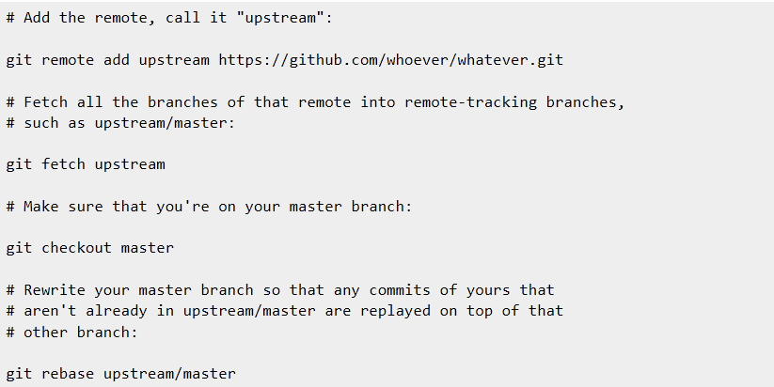

At this point your Aptana repos or desktop cloned repos should be up to date.